The Sunbury Sports Summer Social event

will take place at

Peter and Jean’s house at 13 Riverside, Lower Hampton Rd.

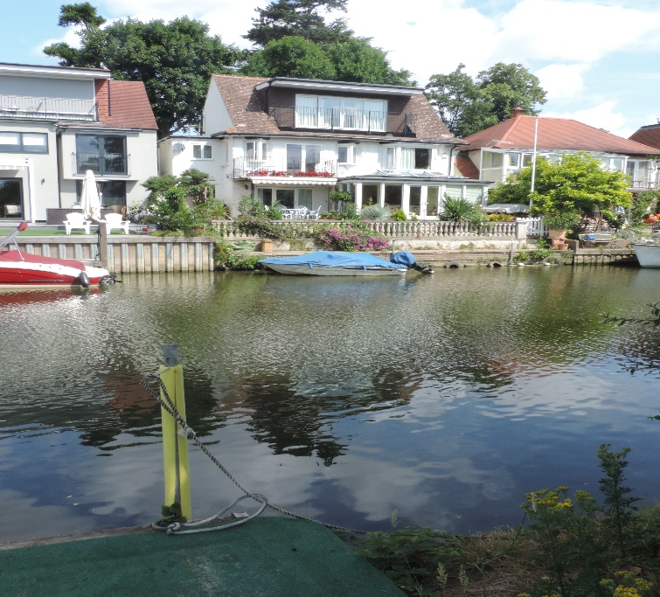

Bowl up at around 5pm for food, drink, puzzles and, weather
permitting, boat rides on the Thames.

Tickets will be on sale at £12 a head shortly.

